LOUISIANA HAWKING ASSOCIATION
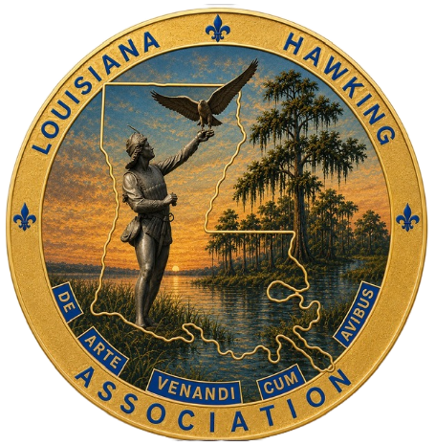
MEMBERSHIP APPLICATION
www. louisianahawkingassociation.org
The purpose of the Louisiana Hawking Association is to promote the pursuit of wild game with raptors as a field sport, and to encourage the conservation of raptors, their prey species, and the environments we share with them.
LHA Membership consists of the following categories:
Apprentice, or Regular: Must be a Louisiana resident AND a licensed Falconer of this state.
Out of State Member: (O.S.M.) Must possess a valid Falconry license from their home state.
Associate: Open to non-licensed falconers.
The LHA’s Annual Membership year runs from Jan 1st through December 31st.
Membership Fee is $20 per year for all levels. All fees are due by Feb 28th each year.
(Please make checks or money orders payable to LOUISIANA HAWKING ASSOCIATION)
NEW MEMBER: ☐ APPRENTICE: ☐ REGULAR: ☐ ASSOCIATE: ☐ RENEWAL: ☐ O.S.M. ☐

Full Name:________________________________________________________________

Street Address______________________________________________________________
:
City:______________________________ State:______ Parish:______________________

Zip Code:___________________ Phone:_________________________

Email:_____________________________________________________
N.A.F.A. Member Yes: ☐ No: ☐
Do you Posses any other Wildlife Permits Yes ☐ No: ☐ Plz Specify____________________

Permit Class: APPRENTICE: ☐ GENERAL: ☐ MASTER: ☐ License #________________
Check or Money Order: ☐ Cash: ☐ Cash App: ☐

Signature:___________________________________________Date:__________________

